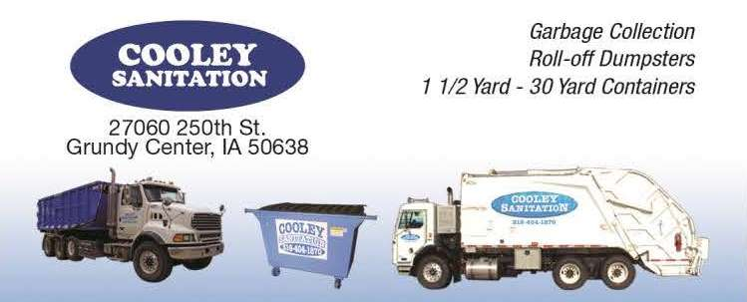

319-345-6080, info@cooleypumping.com

Rules, regulations and sizes for Dumpsters and Roll-Off Containers
- Dumpster available are 1 ½ yard, 2 yard and 6 yard. Roll-off Containers (dumpsters) available are 20 yard and 30 yard.
- For roll –off dumpsters, there is a 21 calendar day use of the container. Please call the Cooley Sanitation office when you need the roll-off emptied or you are finished with it. If you have the roll-off for more than 21 days without having it emptied, you will be charged a per day rental fee from that day until picked up.
- The price for the 20 yard and 30 yard, plus tax and weight fee at the landfill, are a per dump price.
- For 1 ½ and 2 yard dumpsters, make arrangements with the Cooley Sanitation office for getting the dumpster emptied. You can be added to a weekly, bimonthly or monthly dumping schedule. You will need to empty the dumpster at least once in 28 days or you will be charged a rental fee.
- All materials must be level full to the rim of the container. Nothing should extend above the top or sides of the container.
- NO dirt, rocks, concrete, cement, asphalt, blacktop, tile, bricks, gravel, sand, stucco, composition roofing, or any other heavy building or construction material is permitted in any dumpster other than a 6 yard for construction, a 20 yard or 30 yard roll-off dumpster.
**The landfill assesses additional charges (which will be passed along to you) for the following items AND they should be separate from other waste (leave beside the dumpster):
  - Appliances (including microwaves, dehumidifiers and water softeners)
  - Light fixtures, fluorescent bulbs
  - Tires
**The landfill considers the following unacceptable:
(Please do NOT dispose of these items in the dumpster/roll-off)

- Yard waste of any kind
- Full paint cans (empty, dried paint cans are regular garbage)

- Auto hulks
- Batteries
- Raw Sludges
- Dead animals
- Radioactive waste
- Herbicides
- Insecticides
- Pesticides
- All liquids
- Any other toxic or hazardous materials listed by the EPA or DNR

